Figure 3
Unstandardized path coefficients of the latent moderated mediation model (Final)
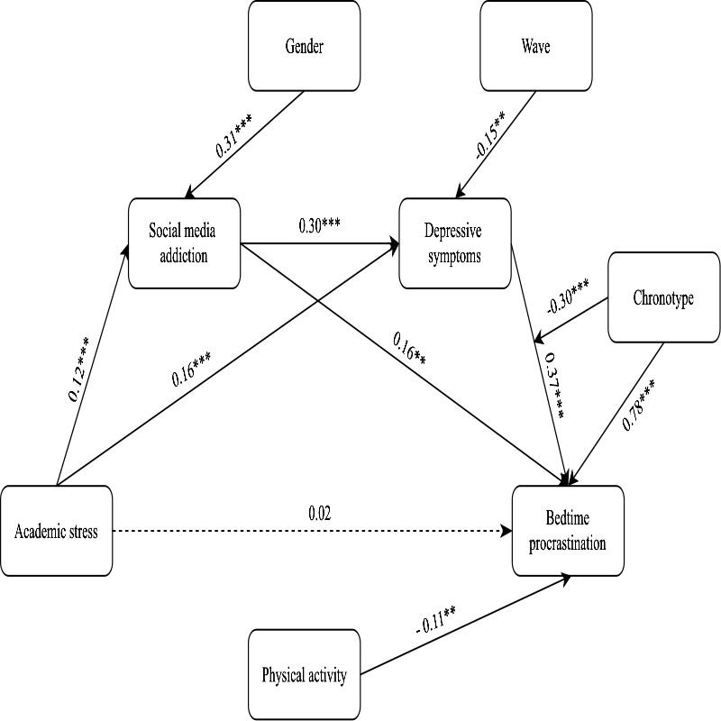
Note. Values represent unstandardized coefficients (B). SM = Social Media Addiction; DP = Depressive Symptom; BP = Bedtime Procrastination. Solid lines indicate statistically significant paths (p<.05); dashed lines indicate non-significant paths (p>.05). The interaction term (Depressive Symptoms × Chronotype) was estimated using the Latent Moderated Structural Equations (LMS) approach with robust standard errors. For visual clarity, non-significant covariate paths (Age, Gender, Wave) are not depicted in the figure but are controlled for.
R² values for endogenous variables are as follows: SM = .12, DP = .30, and BP = .38 in the chain mediation model (Model 2; see Table 4 for full estimates); and SM = .12, DP = .30, and BP = .56 in the moderated mediation model (Model 3; see Table 6 for full estimates). The substantial increase in R² for BP (from .38 to .56) indicates that Chronotype significantly enhances the model's explanatory power for bedtime procrastination.
*p < .05. **p < .01. ***p < .001.

